**UMUTONI FARIDA**

**ID: 23231**

**DATE: 16/12/2023**

**Papeterie Management System Application Documentation Content**

1. Overview
2. Project Requirements
3. Project Plan
4. Database Schema of the application
5. User Documentation.
6. Technical Documentation

* 1. Overview

A Papeterie Management System (PMS) helps stationery stores by organizing products, tracking inventory, managing sales, handling customers and suppliers, and providing reports for informed decision-making. It streamlines operations, enhances efficiency, and improves overall business management.

Requirements of the application

Functional requirements:

1.User authentication: The system should have a secure login mechanism to authenticate vendors, buyers and operations managers.

2.Papeterie stock initiation: vendors should be able to enter all the necessary details about a papeterie stock during the initiation phase, including item name, description, and other relevant information.

3. Ordering reporting: vendors should be able to record and submit stock reports, including details of observations, findings, non-compliance issues, and recommendations for corrective actions.

Non-functional requirements:

* 1. Security: The system should have robust security measures in place to protect user data, prevent unauthorized access, and ensure data privacy.
  2. Usability: The user interface should be intuitive and user-friendly, allowing buyers, vendors , and operations managers to easily navigate and perform their tasks.
  3. Reliability: The system should be reliable and available for use at all times, with minimal disruptions or downtime.
  4. Scalability: The system should be scalable to accommodate the growing number of papeterie stock, vendors, and project managers in the future.
  5. Data backup and recovery: The system should regularly backup data to prevent data loss and have mechanisms in place for data recovery in case of any failures or disasters.
  6. Validation: The system user-interfaces should validate data that is being input to prevent capturing wrong, irrelevant or inaccurate information.

3. Project Plan

Scope

The scope of the Papeterie Management System (PMS) project includes features like product and inventory management, sales and POS functionalities, customer and supplier management, reporting and analytics, security, integration, user-friendly interface, scalability, and support. It aims to streamline stationery store operations and enhance overall business efficiency.

Timeline

This application was developed in a period of two weeks, whereby the requirements definition took one day, designing took two days, design implementation and coding took nine days, testing took one day and deployment took one day.

Resources

I used web technology resources to develop this application. The resources are divided into programming languages like Java, SQL, JavaScript, and CSS; markup languages like HTML; frameworks like Spring MVC, Spring Boot, Spring Data JPA; Servers like Tom Cat and MySQL server; MySQL Workbench client application; and lastly a development environment called Intellij IDEA.

4. Database Schema

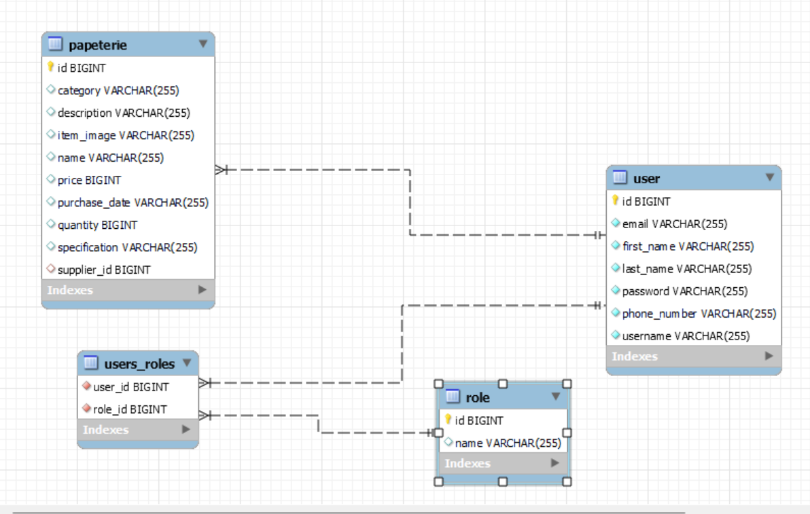

* Users are mapped to their role by ManyToMany relationship.
* Each Papeterie stock is mapped to the responsible inspector by ManyToOne relationship.

5. User Documentation

**Access the application using the URL**: https://inspection-project-final.herokuapp.com/ Login:

Possible credentials

Role: BUYER

* Email: kenntyfabrice8@gmail.com
* Password: fun123
* Phone number (required to reset password): 0783445678

Role: VENDOR

* Email: munezerowilly6@gmail.com
* Password: fun123
* Phone number (required to reset password): 0798345672

Role: OPERATIONS_MANAGER

* Email: umutonifarida5@gmail.com
* Password: fun123
* Phone number (required to reset password): 0789169974

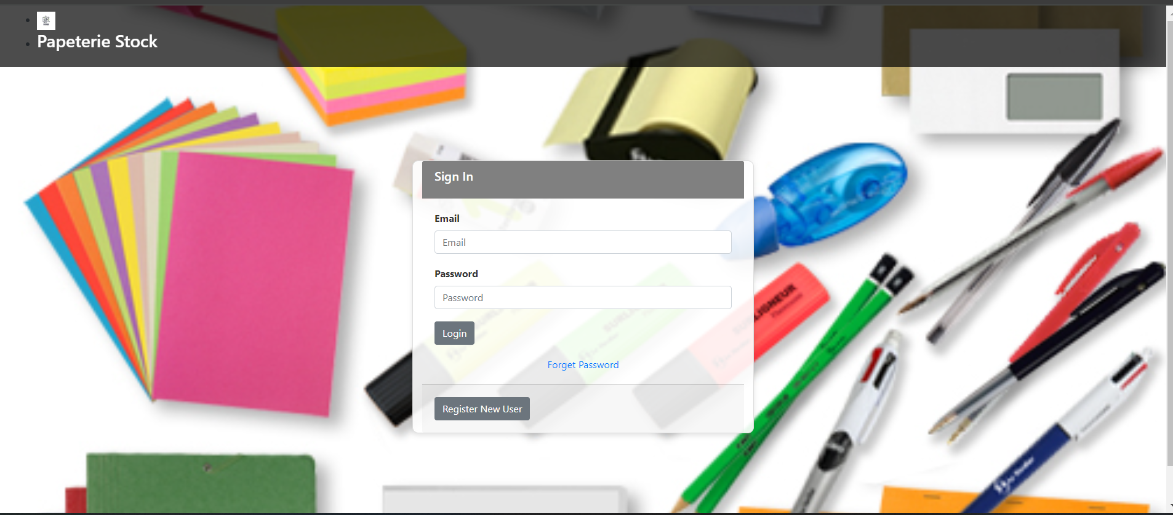

Sign Up form:

This form may be used by a new user to sign up with the relevant roles they will have on the system.

To be able to sign Up successfully, the user must meet all the form validations required.



In case the user forgot their password, they are required to provide their email and phone number that are associated with their account.

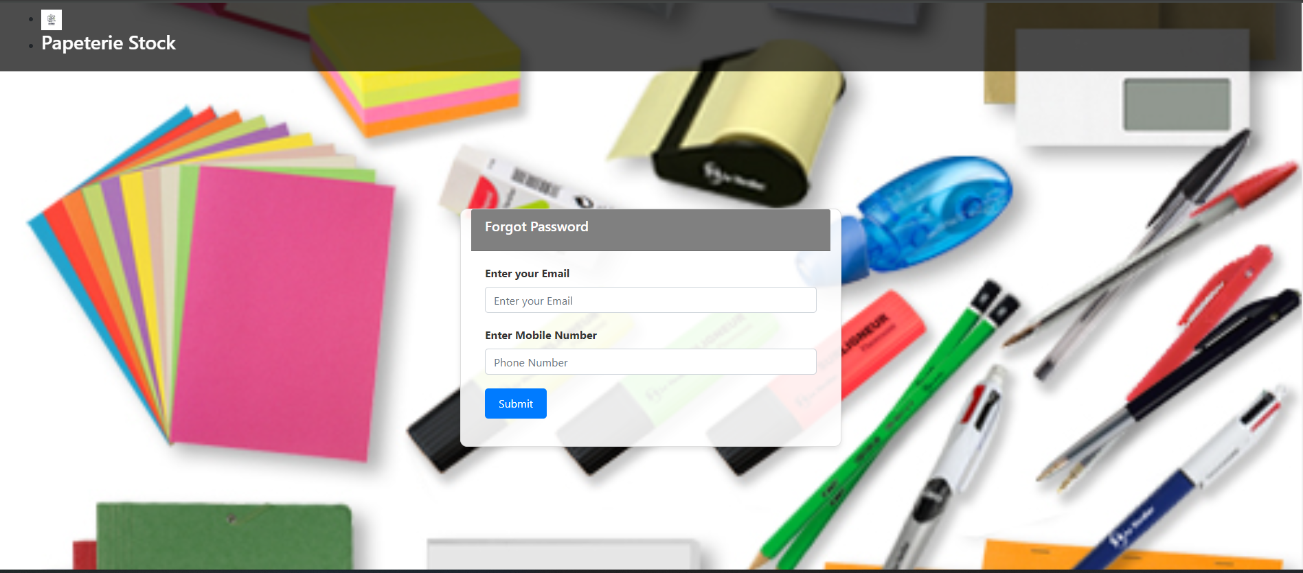

After, the user may get a form to add a new password that shall be used on the next logins.

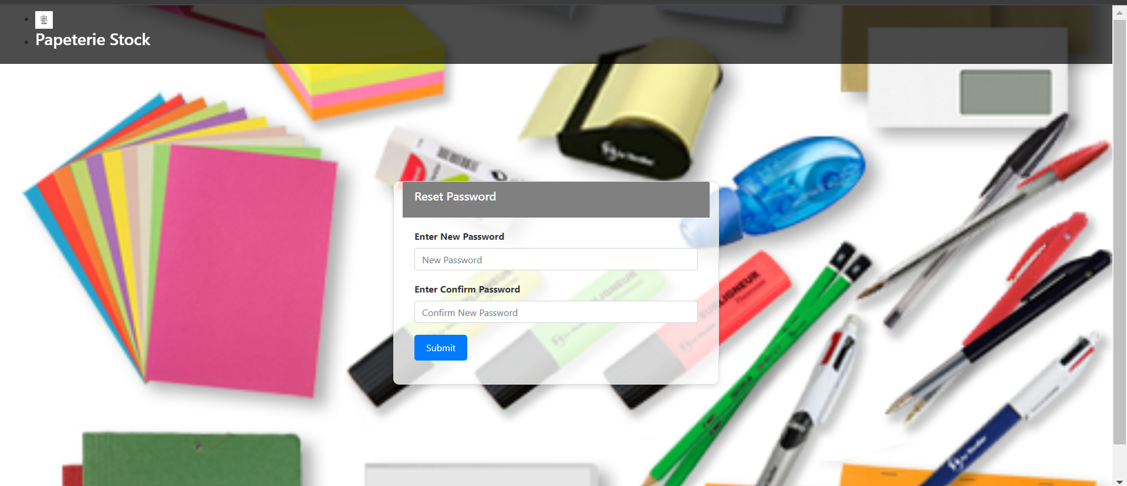

System Dashboard:

This dashboard was developed leveraging spring security to establish view based on roles feature.

Buyer’s Dashboard

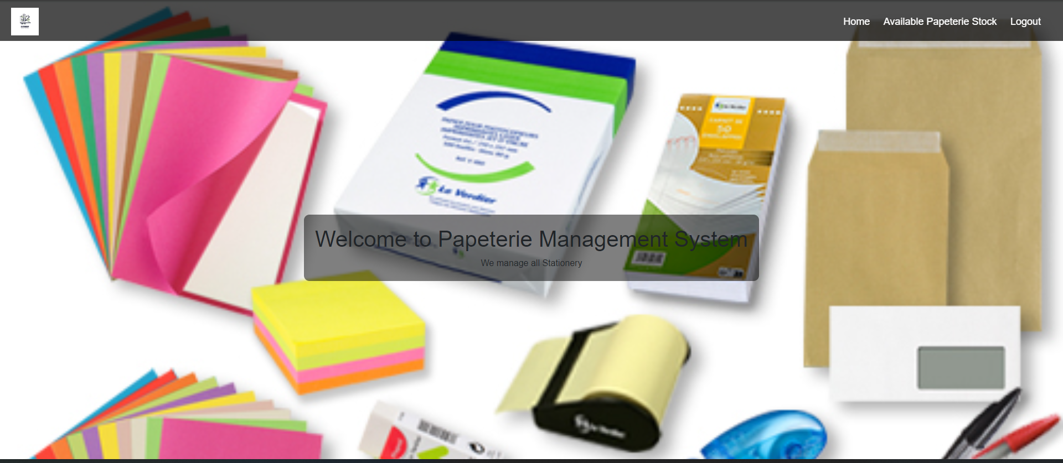

Vendor’s Dashboard

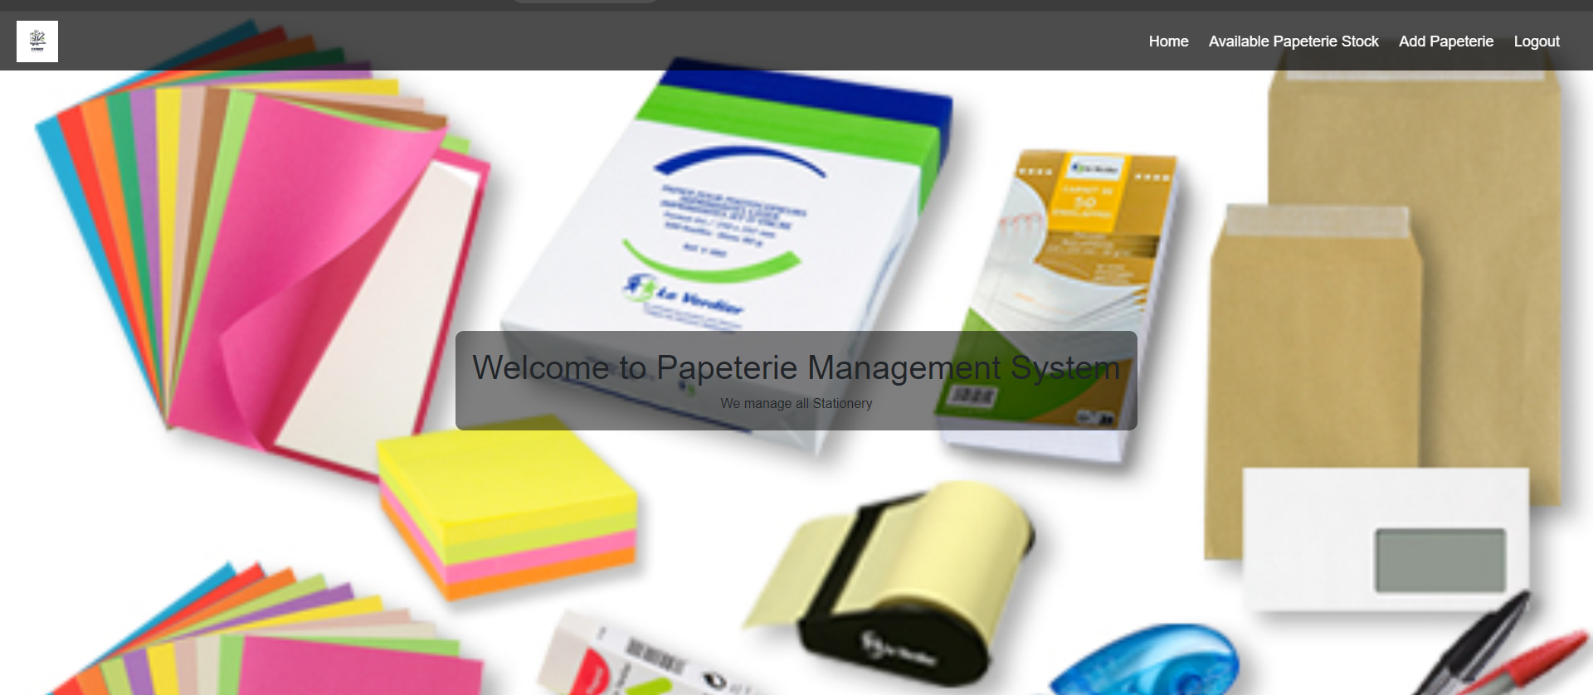

Operations Manager’s Dashboard

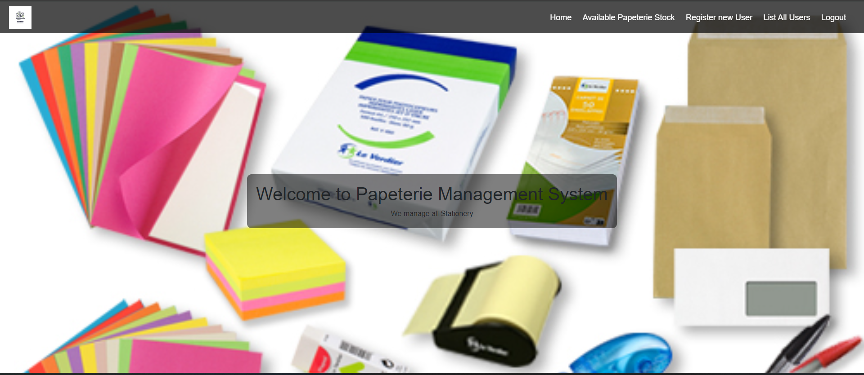

Papeterie initialize form for Vendors



This form will allow a user to initiate a papeterie stock and record the initial state of the project by specifying the title, price, description, the image of item of papeterie stock as well as the masterplan of the project. This page is prepopulated with the id of the logged in user that is capturing the new project.

Listing All Papeterie stock and ordering

Since the application is an online papeterie driven application, the minimum privileges are given to the buyers that carry out the papeterie stock, therefore they can only capture the papeterie stock at initiation stage on the application. They are not allowed to access any further resources on the application such as listing all papeterie stocks, updating the state of stocks or deleting papeterie stock

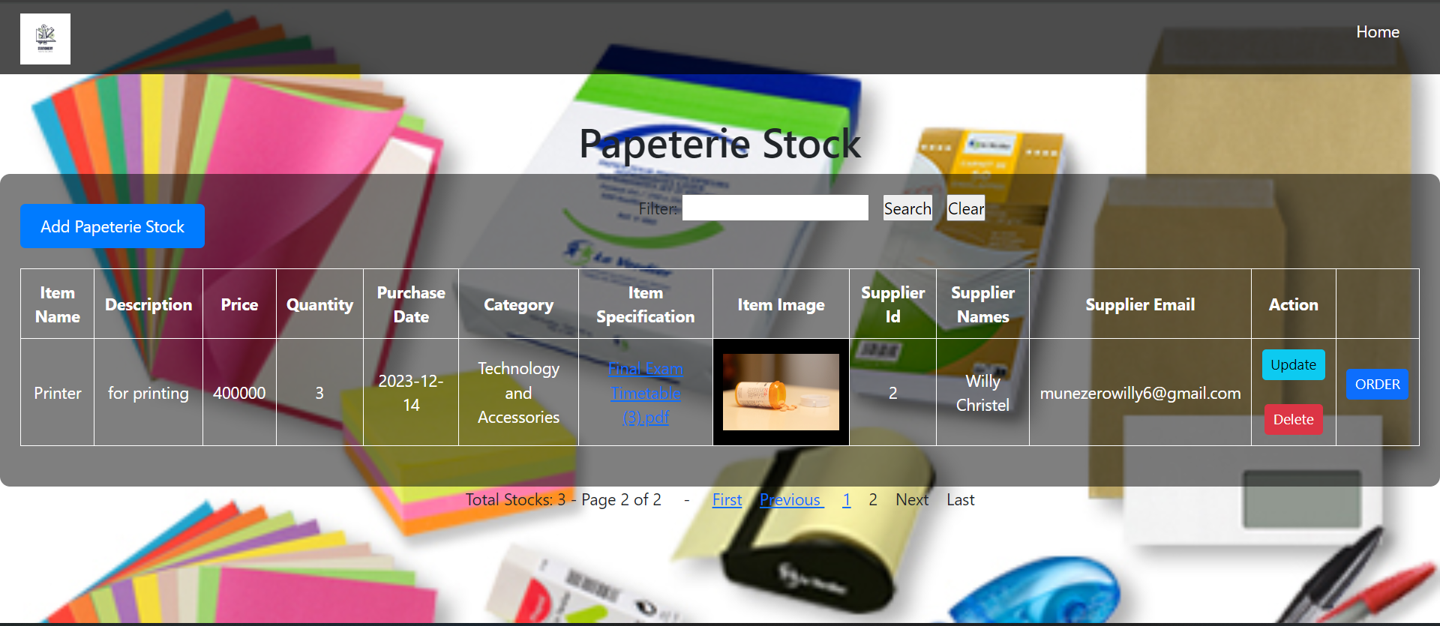

When you list all construction projects, you will get a list of all projects that were captured on the system. The list provided has the pagination feature which lists two projects on each page. You can navigate to other pages of the list using the next, last, previous, first hyperlinks under the list table. There’s also a search and filtering feature, whereby the user may provide a keyword and the list of all matching data will be provided.

NOTE: Only users signed in as INSPECTOR or OPERATIONS_MANAGER can see the **update** button. Also, the **delete** button is not visible to inspectors because only the operations manager are allowed to delete projects on the system. The image below shows the list of projects whereby delete is possible because the signed user has role of OPERATIONS_MANAGER.

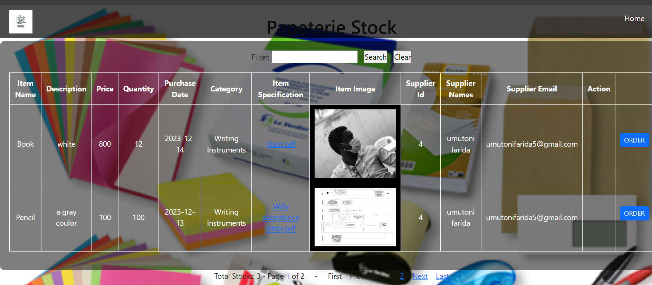

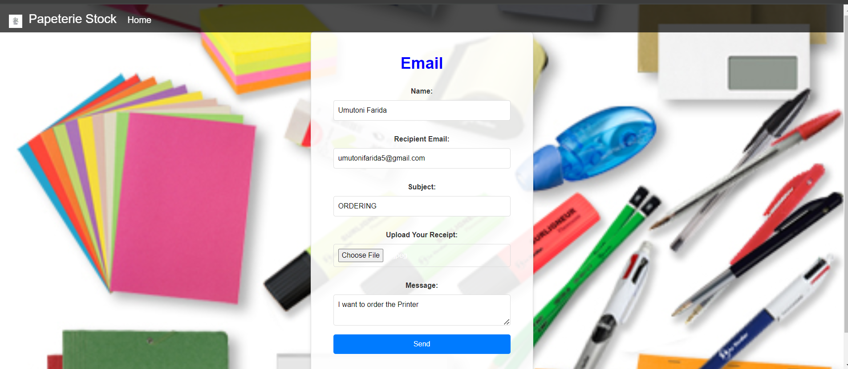

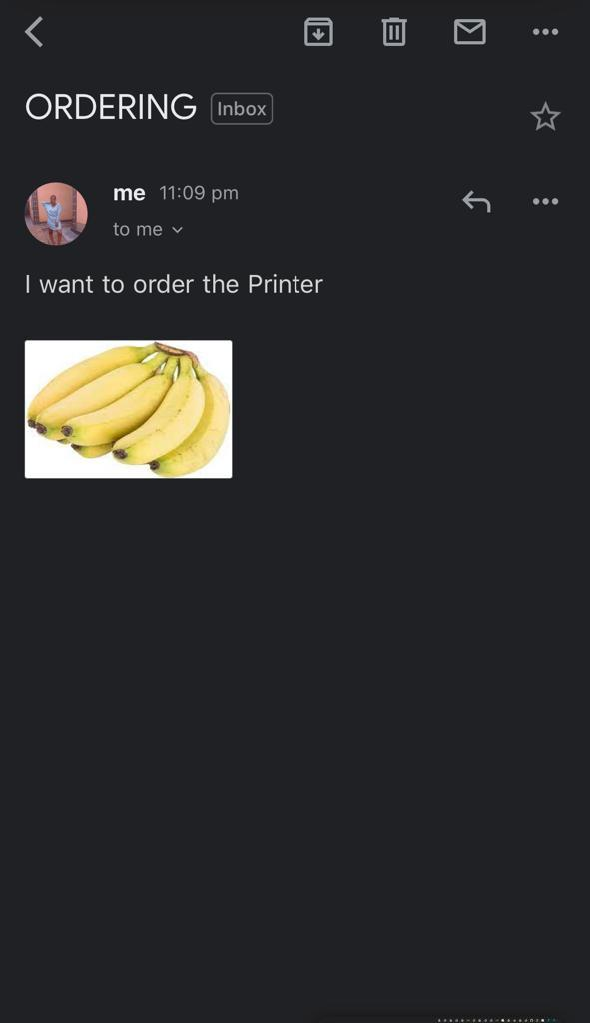

List All users:

Only the operations manager is given a button on the dashboard that allows him/her to list all users that are signed up on the application to view all their credentials.

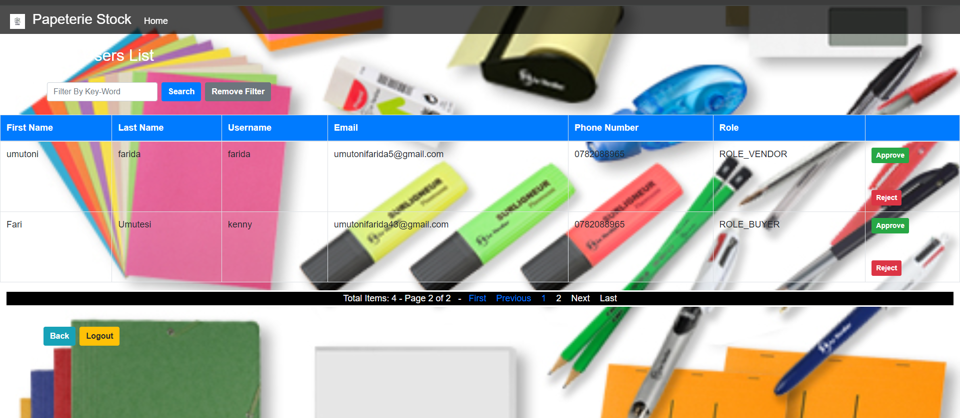



6. Technical Documentation

Architecture of the application

I used spring MVC architecture that stands for spring Model, View and Controller as the architecture of the application.

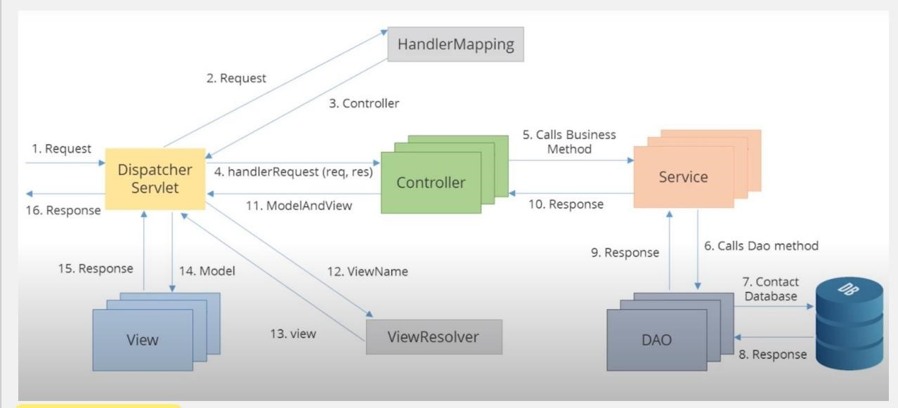

To implement this architecture, I developed a springboot maven application.

* I added a dependency of “**spring-boot-starter-web**”. This dependency includes the necessary libraries for creating web applications with Spring Boot, including the DispatcherServlet. The DispatcherServlet is automatically registered and configured when you include the necessary dependencies in your Maven pom.xml file and annotate your application's main class with @SpringBootApplication.

* I added a dependency of “**spring-boot-starter-thymeleaf**”. The **Handler-Mapping** is responsible for mapping incoming requests to the appropriate controller methods based on defined mappings and rules. It helps determine which controller should handle a specific request URL. When you include the spring-boot-starter-web and spring-bootstarter-thymeleaf dependencies in your Maven pom.xml file, Spring Boot automatically configures the Handler-Mapping as part of its auto-configuration.

* I have a three **Controller** classes namely, “**LoginController**”, “**ManagerController**”, and “**MainController**”. The Manager controller is used to handle requests that are related to signing up new users to the system and setting their roles, the Manager controller is

used to handle requests related to logging in, and password resetting. The Main controller is used to handle requests related to CRUD operations that are to be performed on the main domain model which is the construction projects.

* I have the **service layers** that is an intermediate layer between the controller layer and the data access layer (typically represented by repositories or DAOs). Its main purpose is to encapsulate the business logic of the application and provide a separation of concerns. In my application, I used the userService layer to handle the business logic related to users of the application. Also, I have a projectService layer that handles the business logic related to construction projects persisted on the application.

* I have used the Spring Data JPA framework mainly the interface called **JpaRepository** by adding the dependency “**spring-boot-starter-data-jpa**”. JpaRepository is one of the central interfaces provided by Spring Data JPA. It extends the standard CrudRepository interface and provides additional methods for common database operations such as querying, saving, updating, and deleting entities. JpaRepository also supports pagination, sorting, and other convenience features.

* The **view resolver** in Spring Boot resolves the logical view names returned by the controller methods to the actual view templates that will be rendered and returned to the client. When you include the **spring-boot-starter-thymeleaf** dependency in Maven pom.xml file, Spring Boot automatically configures the view resolver as part of its autoconfiguration.

* **The log-back framework**. Logback is a standalone logging framework for Java applications that provides a flexible and reliable logging solution with many useful features.

* **Spring-boot-starter-validation** is a starter module in Spring Boot that provides support for validation using the Java Bean Validation API. It simplifies the configuration and usage of validation in your Spring Boot application by automatically setting up the necessary components.

* **Spring Cache:** Spring Cache is a caching abstraction provided by the Spring Framework. It allows you to add caching annotations, such as @Cacheable, @CachePut, and @CacheEvict, to your methods.

* **Spring Security:** Spring Security is a comprehensive security framework for Java applications. It offers a wide range of features for securing web applications, including authentication, authorization, and various security mechanisms.

* **MySQL-connector-java:** mysql-connector-java (MySQL Connector/J) is the official JDBC driver for connecting Java applications to MySQL databases.